Dynamics of Income in Bihar: Evidence from Village Studies

K.M.Singh, Abhay Kumar, R.K.P.Singh, M.S.Meena, and Anjani Kumar

Introduction:
The state of Bihar is located between 24°20'10" N to 27°31'15" N latitude and 83°19'50" E to 88°17'14" E longitude. Bihar is the third most populous state of the country, with a population density of 1102 persons per square kilometer, inhabiting a little more than 8.6 per cent of the country’s population. A large portion, about 53.5 per cent, of the population lives below the poverty line (Planning Commission, 2012). Bihar agriculture is dominated by small land holders. About 96 per cent farm households have less than 2 hectares land and they own 67 per cent of agricultural land in Bihar. Marginal farmers (< 1 ha.) constitute about 90 per cent of total farm households and they own about 43 per cent of agricultural land in Bihar (Singh, 2009), The State is ranked lowest in the country in terms of per capita income. Out of the total 150 disadvantaged districts of the country identified by the Planning Commission, 15 districts are located in Bihar. Agricultural development holds key to improve livelihoods in Bihar where nearly 70 per cent population depends directly or indirectly on agriculture which contributes 19 per cent to state GDP against 16 per cent at the national level.
The state is endowed with rich natural resources, but its potential could not be harnessed in terms of improving agricultural productivity, poverty alleviation and rural livelihood improvement. The state has a total cultivable area of 6.64 m ha with a cropping intensity index of 140. Soils are mainly alluvial developed from alluvium brought by the various rivers of the state. Annual normal rainfall is 1176.4 mm, with 80% of the rain occurring during four months of monsoon season (June- September). About 61% of the net sown area is irrigated. The frequent occurrence of flood and drought is also common phenomenon in the state, thereby, affecting agricultural production and rural livelihood. Bihar is a true example of a ‘resource rich state’ inhabited by ‘poor people’. Agriculture in Bihar is faced with major challenges like low productivity, regional disparities and low level of diversification of agriculture into non-food crops and commercial crops and allied enterprises.
Data and Methodology
The study is based on data collected under the project entitled “Tracking change in rural poverty in household and village economies in Eastern India”. Data were collected from sample households through panel interview method in four villages namely; Arap, Baghakole, Inai and Susari. First two villages are located in comparatively developed district (Patna) with respect to ecological situation, agricultural development, and infrastructure facilities, whereas the other two villages are located in comparatively undeveloped district (Darbhanga). Developed villages are drought prone but have canal irrigation facility which however, does not provide regular and adequate water. Less developed villages are flood prone and dependent on ground water irrigation for crop production. All the four villages are connected with motorable road but former are near to national highway whereas later villages are located at a distance of more than 40 km from national highway. Education level of developed villages is higher than less developed villages. Non-farm is the main source of income in less developed villages whereas one of developed villages generates more than half of income from farm sector (Appendix-I). Per capita land is about half in less developed villages as compared to per capita land in developed villages. Per acre fertilizer consumption, seed replacement rate and number of pump set are much higher in developed villages than less developed villages. A sample of 40 households, 10 from each category of households i.e.; Labour, Small, Medium and Large were selected randomly in each of four villages, making sample size of 160 households in Bihar.
Income trend
Among the major states of the country, per capita income is the lowest in Bihar, however, it increased from to ? 5944 in 1993-94 to ? 7650 in 2004-05 and further increased to ?10614 in 2009-10 (Table-1).Annual growth in income is worked out to be 3.8 per cent during last two decades but the comparatively high increase is observed during last five years (2004-05 to 2009-10). The higher increase in income during last five year is mainly due to increase in agricultural and livestock productivity and large scale construction activities in various projects

Table1: Per capita income in Bihar during 1993-94-2009-10 (?/Person/year)
Year | Bihar
TE 1993-94 | 5944
TE 2004-05 | 7650
TE 2009-10 | 10614
Compound Annual Growth Rate (% per Annum)
1993-94 to 2004-05 | 2.7
2004-05 to 2009-10 | 8.7
1993-94 to 2009-10 | 3.8

Per capita income was also worked out on the basis of data obtained from 160 households of four villages in Bihar (Table 2). Per capita income is comparatively high in Arap village (Rs1737) followed by Baghakole (Rs1661), Inai (Rs1116) and Susari (Rs509). Per capita income in Arap village is more than three - fold higher than per capita income in Susari village.
Figure 1: Per capita income (Rs.) in selected villages of Bihar
Comparatively high income in Arap is mainly due to large number of full time employed persons in government and non-government organizations whereas the least per capita income in Susari village is mainly due to loss in livestock production, absence of fully employed/ retired person in the households under study (Appendix-I). Family size is also comparatively large in Susari than other villages under study. As expected, per capita income is higher on large households and lower on labour households, however, gap between income of large and labour households is comparatively low in high income earning villages and the gap increases with decline in earning level in the village. Susari village is an exception because there is no much difference among households with respect to per capita income.
Table 2: Average per capita income (Rs./person/month) in selected villages in Bihar
Village | Labour | Small | Medium | Large | All
Arap | 696.8 | 2123.4 | 1386.8 | 2698.7 | 1737.3
Baghakole | 815.2 | 1123.8 | 1012.5 | 2946.0 | 1661.0
Inai | 438.3 | 698.0 | 1161.8 | 1878.5 | 1115.9
Susari | 449.6 | 572.2 | 458.5 | 565.9 | 508.9

Sources of Income
While analyzing sources of income, agriculture is major source of income only in Baghakole village (52%) whereas non-farm sector is major source of income in other three villages under study. Baghakole is agriculturally developed village hence agricultural income is higher on all the land owning households in the village. Non - farm is the main source of income in three villages however the contribution of this source is much higher(88%) in Inai and Susari village ,mainly due to small land holdings and undeveloped agriculture (Appendix I). Remittances from migrant labour and/or permanent employed persons are the main sources of income in all the villages under study (Table 3). It constitutes about two- thirds of income in Susari and Arap, one-half in Inai and one-third in Baghakole. All the remittances is sent by labour migrants in Susari village, major portion of remittances flow through labour migrants in Inai whereas the major portion of remittances is received in Arap and Baghakole village from permanent employed persons within and outside state. In Susari village, remittances constitute about 92 per cent of total household income because extent of migration is much higher in the village (73 %).
Table 3: Percent income from migration (%) in Bihar
Village | Labour | Small | Medium | Large | All
Arap | 38.9 | 79.0 | 69.6 | 51.0 | 61.4
Baghakole | 18.6 | 60.7 | 14.9 | 28.0 | 30.4
Inai | 42.2 | 66.8 | 59.3 | 40.2 | 48.6
Susari | 92.3 | 48.3 | 78.5 | 45.1 | 64.4

Diversity of income
Sources of income are comparatively large on high income category and a few on low income category of households. Sources of income in villages and households are computed to test this hypothesis in Bihar context. But the sources of income is comparatively low in Arap village where per capita income is comparatively high (Table 4). However, the lowest number income sources are found in Susari village where per capita income is also the lowest. Sources of income are much high in Inai village (3.8) but per capita income is not higher than all the villages under study. It may be due to small size of land holding and they might have tried to earn income through different sources for survival. Despite the lowest per capita income in Susari, income sources are the least diversified because about half of households belong to forward caste category but own smaller landholdings who do not like to work as farm and non-farm labour, artisan and construction worker due to social stigma and prefer to migrate. Hence, income diversity indices are low in the village. The diversification indices also tell the same story (Table 5).
Table 4: Diversity in income in Bihar (No. of sources per household)
Village | Labour | Small | Medium | Large | All
Arap | 2.4 | 2.9 | 3.0 | 2.8 | 2.8
Baghakole | 3.6 | 3.0 | 2.6 | 3.1 | 3.1
Inai | 3.3 | 4.4 | 3.8 | 3.9 | 3.8
Susari | 1.7 | 3.0 | 2.6 | 2.7 | 2.5

While analyzing the household category wise income sources and diversity indices, it has been observed that the no. of sources of income is not higher on large category of household in any of villages under study (Table 4 & 5). But it was the lowest on labour households in three villages under study, except Baghakole where sources of income is the highest on labour households (3.6). The similar pattern has been observed in case of income diversity indices. There is no specific trend in income diversification indices across the different categories of households under study.
Table 5: Diversification indices of income sources in Bihar
Village | Labour | Small | Medium | Large | All
Arap | 0.30 | 0.46 | 0.46 | 0.44 | 0.41
Baghakole | 0.52 | 0.54 | 0.50 | 0.44 | 0.50
Inai | 0.41 | 0.57 | 0.46 | 0.48 | 0.48
Susari | 0.08 | 0.44 | 0.54 | 0.51 | 0.39

Distribution of Income
While examining the distribution of income, Lorenz curve is used to have an idea about the degree of inequality that exists across villages and categories of households. To examine the variability in income among villages and households under study, Lorenz curves were plotted and the corresponding Gini ratio were computed (Table 6).
Table 6: Income inequality (Gini ratio) in selected villages in Bihar
Village | Labour | Small | Medium | Large | All
Arap | 0.16 | 0.34 | 0.36 | 0.36 | 0.41
Baghakole | 0.18 | 0.39 | 0.37 | 0.34 | 0.44
Inai | 0.16 | 0.63 | 0.27 | 0.50 | 0.54
Susari | 0.23 | 0.40 | 0.34 | 0.37 | 0.36
The higher Gini coefficient indicates more unequal distribution and lower value means more equal distribution. Among villages under study, Gini coefficient ratio is comparatively high for Inai village (0.54), indicating a higher level of inequality in income in this village where as Gini coefficients are low and almost similar (.0.41 & 44) for Arap and Baghakole, indicating comparatively more equality in income distribution (Figure 2 to Figure 5). The lowest Coefficient is found in Susari village where income level is also the lowest. Among household categories, the income level is lower in labour households but distribution of income is also more equal as compared to other categories of households. Attempt has been made to find out the sources of inequality and found that the diversity of income and level of education are responsible for inequality in income among household categories under study. Hence, it may be inferred that an increase in income is mainly concentrated among prosperous households, whose income is more diversified and their family members are more educated. There is a need to promote education among poor households which will help in diversifying their sources of income.
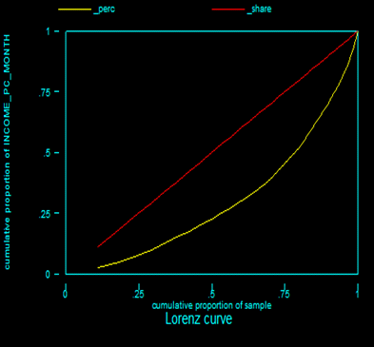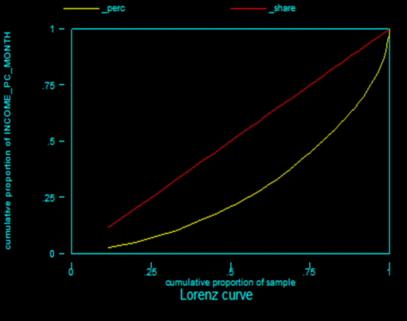
Figure 2: Lorenz curve of per capita income Figure 3: Lorenz curve of per capita income
per month: Arap per month: Baghakole

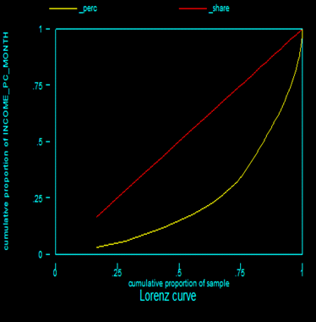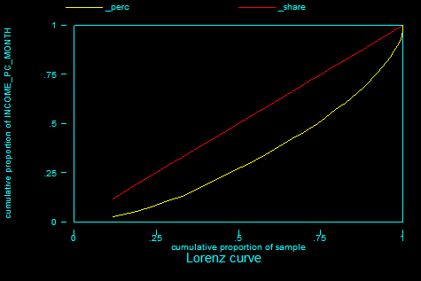
Figure 4: Lorenz curve of per capita income Figure 5: Lorenz curve of per capita income
per month: Inai per month: Susari

Determinants of income
While analyzing the household income, it has been observed that there is no any specific trend in sources of income and inequality in income in any of the villages under study in Bihar. Hence, a regression equation was estimated in linear form to assess the contribution of different factors to per capita income of households (Table 7).
Table 7: Coefficients and standard error of estimates of variables of determinants of income in Bihar
Dependent variable – Per capita income per month (Rs.)
 | Coefficient | Robust standard error
Average age (years)[X1] | -0.7515 | 0.4754
Average education (years) [X2] | 0.8609*** | 0.2333
Household size (no.) [X3] | -0.4550 | 0.3930
Own land (acre) [X4] | 0.0588 | 0.1240
Livestock herd-size (no.) [X5] | 0.2068 | 0.1911
Farm asset value (Rs.) [X6] | 0.0471 | 0.0499
Earning member (no.) [X7] | 0.5573* | 0.3248
Share of non-farm (%)[X8] | -0.6270 | 0.4375
Migration (yes-1, otherwise-0) [X9] | 0.2367 | 0.2334
Area under high yielding variety (%)[X10] | -0.2609 | 0.3684
Constant | 11.3705*** | 3.2480
No. of observation | 65
R-squared | 0.5058
Root MSE | 0.7438
*** Significant at 1 per cent level, ** Significant at 5 per cent level, * Significant at 10 per cent level

Per capita income is taken as dependent variable (Y) and independent variables are average age in years (X1), average education in years (X2), household size (X3), own land in acre (X4), livestock herd-size (X5), farm asset value in ? (X6), earning no. of members (X7), share of non-farm in percentage (X8), migration as dummy variable i.e., yes-1, otherwise-0 (X9), and area under high yielding variety in percentage (X10). The estimated coefficient of multiple determination (R2) is 0.5058, indicating that variables included in the model explain about 51 percent variation in per capita income of households under study. The coefficient of education level of households is positive (0.8609) and significant, indicating that an increase of one percent in education level of households may increase the income by 0.86 percent. An increase in income results in skill improvement and opportunity for getting more employment, which is likely to increase per capita income of households under study. The coefficient of number of earning members is positive (0.5573) and significant, indicating that an increase in number of earning members may increase per capita income of the family. Hence the improvement in the human capital content of family member would further increase income and improve income distribution scenario in rural area. Coefficients of own land, livestock herd size, farm assets and migration are positive but these coefficients are not statistically significant.

Conclusions:
On the basis of above discussions, it may be inferred that the per capita income increased by about two – fold during last two decades in Bihar but increase was higher during last five years mainly due to increase in crop and livestock productivity and more employment opportunities in even rural areas. Per capita income differs significantly from one village to another village, mainly due to per capita land and educational level. Non - farm employment is main source of income and income through migration is much higher in all the villages. There is no trend in diversity of income but it is more on large households than labour households. The inequality of income is higher on large households than labour households, mainly due to higher level of education and income diversification on these households. Educational level and number of earning members in the households are main determinants of per capita income because an increase in educational level increases skill and access to more remunerative employment, hence increase in income of households. Number of earning members is directly related to income because higher the number of earners in the family, higher the level of income.

References
ASSOCHAM India Report (2012). Rural development in India: State level experiences. The Associated Chambers of Commerce and Industry of India, New Delhi. Available: http://www.assocham.org/arb/general/Rural_Development_in_India_state_level_Exp-2012.pdf
Bhatt, B P; Abdul Haris, A; Islam, A; Dey, A; Mukherjee, J; Barari, S K; Das, B and Kaushal, D K (2011). Agriculture in Eastern States: Opportunities and Challenges, Technical Bulletin No. R-31/PAT-20, ICAR Research complex for Eastern region, Patna.
Janaiah, A; Manik, L Bose and Agarwal, A G (2000). Poverty and Income Distribution in Rainfed and Irrigated Ecosystem: Village Studied In Chhattisgarh, Economic and Political Weekly, 35(10):4664-69
Mehtabul Azam and Abusaleh Shariff (2011). Income inequality in Rural India:Decomposing the Gini by income sources, Economic Bulletin,Vol.31 (1):739-748. http://www.accessecon.com/Pubs/EB/2011/Volume31/EB-11-V31-I1-P71.pdf
Planning Commission (2012). Press Note on Poverty Estimates, 2009-10. Planning Commission, Government of India (press_pov1903.pdf )
Singh, R K P (2009). Challenges and Opportunities of Agricultural Development in Bihar, State Farmers Commission, Bihar, Patna
Singh, Krishna M.; Meena, M. S.; Kumar, Abhay and Singh, R. K. P., Socio-Economic Determinants of Rural Poverty: An Empirical Exploration of Jharkhand State, India (September 13, 2011). Available at SSRN: http://ssrn.com/abstract=2017593 or http://dx.doi.org/10.2139/ssrn.2017593
Singh, Krishna M.; Meena, M. S.; Singh, R. K. P. and Kumar, Abhay, Dimensions of Poverty in Bihar (September 13, 2011). Available at SSRN: http://ssrn.com/abstract=2017506 or http://dx.doi.org/10.2139/ssrn.2017506
Singh, R. K. P., Singh, Krishna M. and Jha, A. K., Effect of Migration on Agricultural Productivity and Women Empowerment in Bihar (July 17, 2012). Available at SSRN: http://ssrn.com/abstract=2111155 or http://dx.doi.org/10.2139/ssrn.2111155
Singh, R.K.P. and Thelma, R. Paris. (2004). Impact Of Labour Out-Migration On Rice Based Household Economy And Gender Roles In Bihar; Rau & Irri(Philippines, Collaborative Project, Rajendra Agricultural University, Pusa, Samastipur,Bihar
Thakur,J; Bose, Manik L; Hussain, M And Janaiah, A (2000). Rural Income Distribution and Poverty in Bihar: Insights from Village Studies, Economic and Political Weekly, 35(10):4657-4663
Tilak, J B G (1989). Education and its Relation to Economic Growth, Poverty and Income Distribution, World Bank Comparative Studies, Research Paper No. 3, The World Bank

Appendix-I:
Composition of income (%) in Bihar
Village | Income for Farm | Income from  Non – farm work
Arap | 24.16 | 75.85
Baghakole | 52.37 | 47.63
Inai | 11.05 | 88.95
Susari | 12.37 | 87.64

Head, Division of Socio-Economics and Extension, ICAR-RCER, Patna-14
Senior Scientist (Agril. Statistics), ICAR-RCER, Patna-14
Consultant, VDSA Project, NCAP, New Delhi-12
Senior Scientist ( Agricultural Extension), ICAR-RCER, Patna-14
Principal Scientist (Ag. Econ.), NCAP, New Delhi – On deputation to ICRISAT, Hyderabad

