Information and Communication Technologies for Sustainable Natural Resource Management
M. S. Meena, and K. M. Singh
ICAR Research Complex for Eastern Region, Patna

Abstract
The natural resources of most developing countries are under increasing stress, and many nations are increasingly concerned about achieving environmental sustainability through efficient use of land and water resources. As population is escalating very fast and consumer demand for high value agricultural products (fruits and vegetables, animal or fish products, etc.) is also changing rapidly. Hence, there is need to take stronger step by national government to monitor their natural resources and take immediate steps to maintain these resources when being overused. Data generation by visiting the place physically is tedious and time consuming.

Modern ICT techniques provide the solution helpful in collecting data without visiting the place from distance. With development of modern technologies, ICTs are of immense use in Sustainable Natural Resource Management. These technologies are time and money saving, accurate compared to conventional assessment. Products of these technologies help the scientists and policy makers for taking appropriate decision in agriculture production. It is thus important to recognize that the dissemination of these land and water-use management practices are largely knowledge-based; therefore, developing countries will be required to make substantial investment in public extension to train small and medium-scale farmers how to use Sustainable Natural Resource Management (SNRM) practices.

Introduction
The natural resources of most developing countries are under increasing stress, and many nations are increasingly concerned about achieving environmental sustainability through efficient use of land and water resources. As population is escalating very fast and consumer demand for high value agricultural products (fruits and vegetables, animal or fish products, etc.) is also changing rapidly. Hence, there is need to take stronger step by national government to monitor their natural resources and take immediate steps to maintain these resources when being overused. The eastern region of India, a “low productivity-high potential region”, embraces secure for a second green revolution through holistic management of land, water, crops, biomass, horticulture, livestock, fishery and human resources. The region, through endowed with rich natural resources, lacks in capitalizing on these resources for betterment of agriculture. The potential of eastern region of India is still to be harnessed in terms of improving agricultural productivity, poverty alleviation and livelihood improvement through judicious use of natural resources. The actual productivity gap is very high in the region which could be bridged up to a great extent through the efficient use of information and communication technologies (ICTs). Harnessing the potential of ICTs as an instrument is crucial for inclusive growth of agricultural sector as India.
Data generation by visiting the place physically is tedious and time consuming. Modern ICT techniques provide the solution helpful in collecting data without visiting the place from distance. According to the European Commission, the importance of ICTs lies less in technology itself than in its ability to create greater access to information and communication in underserved populations. The ICT based tools are applied for processing, exchanging and managing data, information and knowledge management, and also having great ability to;

- Record text, drawings, photographs, audio, video, process descriptions, and other information in digital formats,
- Produce exact duplicates of such information at significantly lower cost,
- Transfer information and knowledge rapidly over large distances through communications networks.
- Develop standardized algorithms to large quantities of information relatively rapidly.
- Achieve greater interactivity in communicating, evaluating, producing and sharing useful information and knowledge.

- ICT for Efficient Soil Management
Soil is an important resource, has a specific kind of capacity to function within natural or managed ecosystem boundaries to sustain plant and animal productivity, maintain or enhance water and air quality and support human health and habitation. Soil functions are general capabilities of soils that are important for various agricultural, environmental, nature protection, landscape architecture and urban applications. The major soil functions are:
- Sustaining biological activity, diversity, and productivity;
- Regulating and partitioning water and solute flow;
- Filtering and buffering, degrading, immobilizing, and detoxifying organic and inorganic materials, including industrial and municipal by-products and atmospheric deposition;
- Storing and cycling nutrients and other elements within the earth’s biosphere; and;
- Providing support of socioeconomic structures and protection for archeological treasures associated with human habitation.
Data generation is possible without visiting the place physically through modern ICT techniques. Remote sensing is any process that collects data about an object from a remote location. Some mechanical devices are used to achieve this process. These devices contain advanced sensors that can capture information via the reflection or emission of radiation from objects. Devices used for remote sensing are constructed to sense certain wavelength bands. The objects that are sensed have particular spectral signatures and one has to match the object to the sensor. The area reported with productivity decline is demarcated. Remote sensing products are collected and interpreted either visually or digitally for low productivity.
  - Aerial photographs: The simplest form of remote sensing uses photographic cameras to record information from visible or near infrared wavelengths. In the beginning cameras were positioned above the Earth's surface in balloons or kites to take oblique aerial photographs of the landscape. Many of these images were used to construct topographic and other types of reference maps of the natural and human-made features found on the Earth's surface. Soil quality can be assessed from aerial photography. Areas without vegetation, with high reflectance, irregular in shape are demarcated and it can be examined for eroded or salt affected lands. Figure-1 shows the areas of salt affected lands with high reflectance. Even with cropped area will communicate differently through its high reflection if the soils have problems. Water logging, salinity, low nutrients etc., will affect the plants by reducing uptake of nutrients. Light or pale colour the plants indicates the low nutrient uptake status.

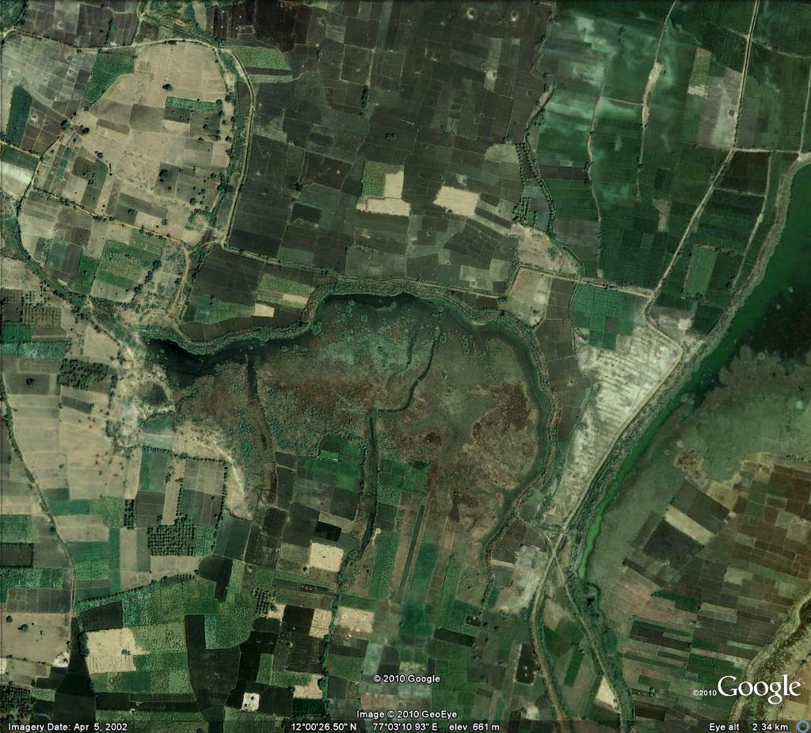
Salt affected land
Salt affected land

Fig. 1 Aerial photographs of salt affected lands-Chamrajnagar District, Karnataka
Source: (Rajan and Meena, 2012)
Repeated photographs with different time interval will be useful for monitoring of soil quality status and assessment. Similar work was done and physical quality was assessed by Fieldli et al. (1997) of the soil restored after the gravel exploration in Switzerland. In order to minimize the soil damage, Infra Red (IR) colour photographs were taken at a scale of 1:3000 from an aircraft using a photogrammetric camera and at a scale of 1:1000 and 1:500 from a gas balloon using an amateur camera. The following results were emerged from the present investigation that to assess the grass condition which was grown on restored areas, aerial photographs at a scale of 1:3000 are better suited than photographs at a scale of 1:1000 and larger scales. The IR colour photographs taken with a photogrammetric camera from an aircraft have a better image quality than the photographs produced with amateur cameras and films. The visual interpretation of the geometrically corrected images was adequate, because the final image was affected by many factors besides soil conditions. Aerial photography has the advantage of allowing a quick and repeatable look at grass conditions over a total area simultaneously, and of providing permanent records of conditions at a specific moment in time.
1.2 Satellite imagery: Development and launching of high altitude satellite caused a revolution in remote sensing. Many orbiting objects were fitted with sensors to complete specific remote sensing jobs. Remote sensing of Earth's climate for weather forecasting began with launching of a number of satellites called TIROS. Over time sensors became more sophisticated and some of them were used to monitor the Earth's surface for a number of applications outside of weather forecasting (LANDSAT, SPOT, and RADARSAT). Recognizing objects from a remotely sensed image is often a difficult process. Many objects are hard to identify because their appearance in image is unfamiliar to our memories because the objects in the environment mainly from an oblique perspective. Objects that are remotely sensed are often imaged from above and the sensors used in the imaging process may be recording electromagnetic signatures that are outside human vision. To aid in object recognition, users often use a methodical process that identifies features based on shape, image tone or color, pattern, shadow, and texture.
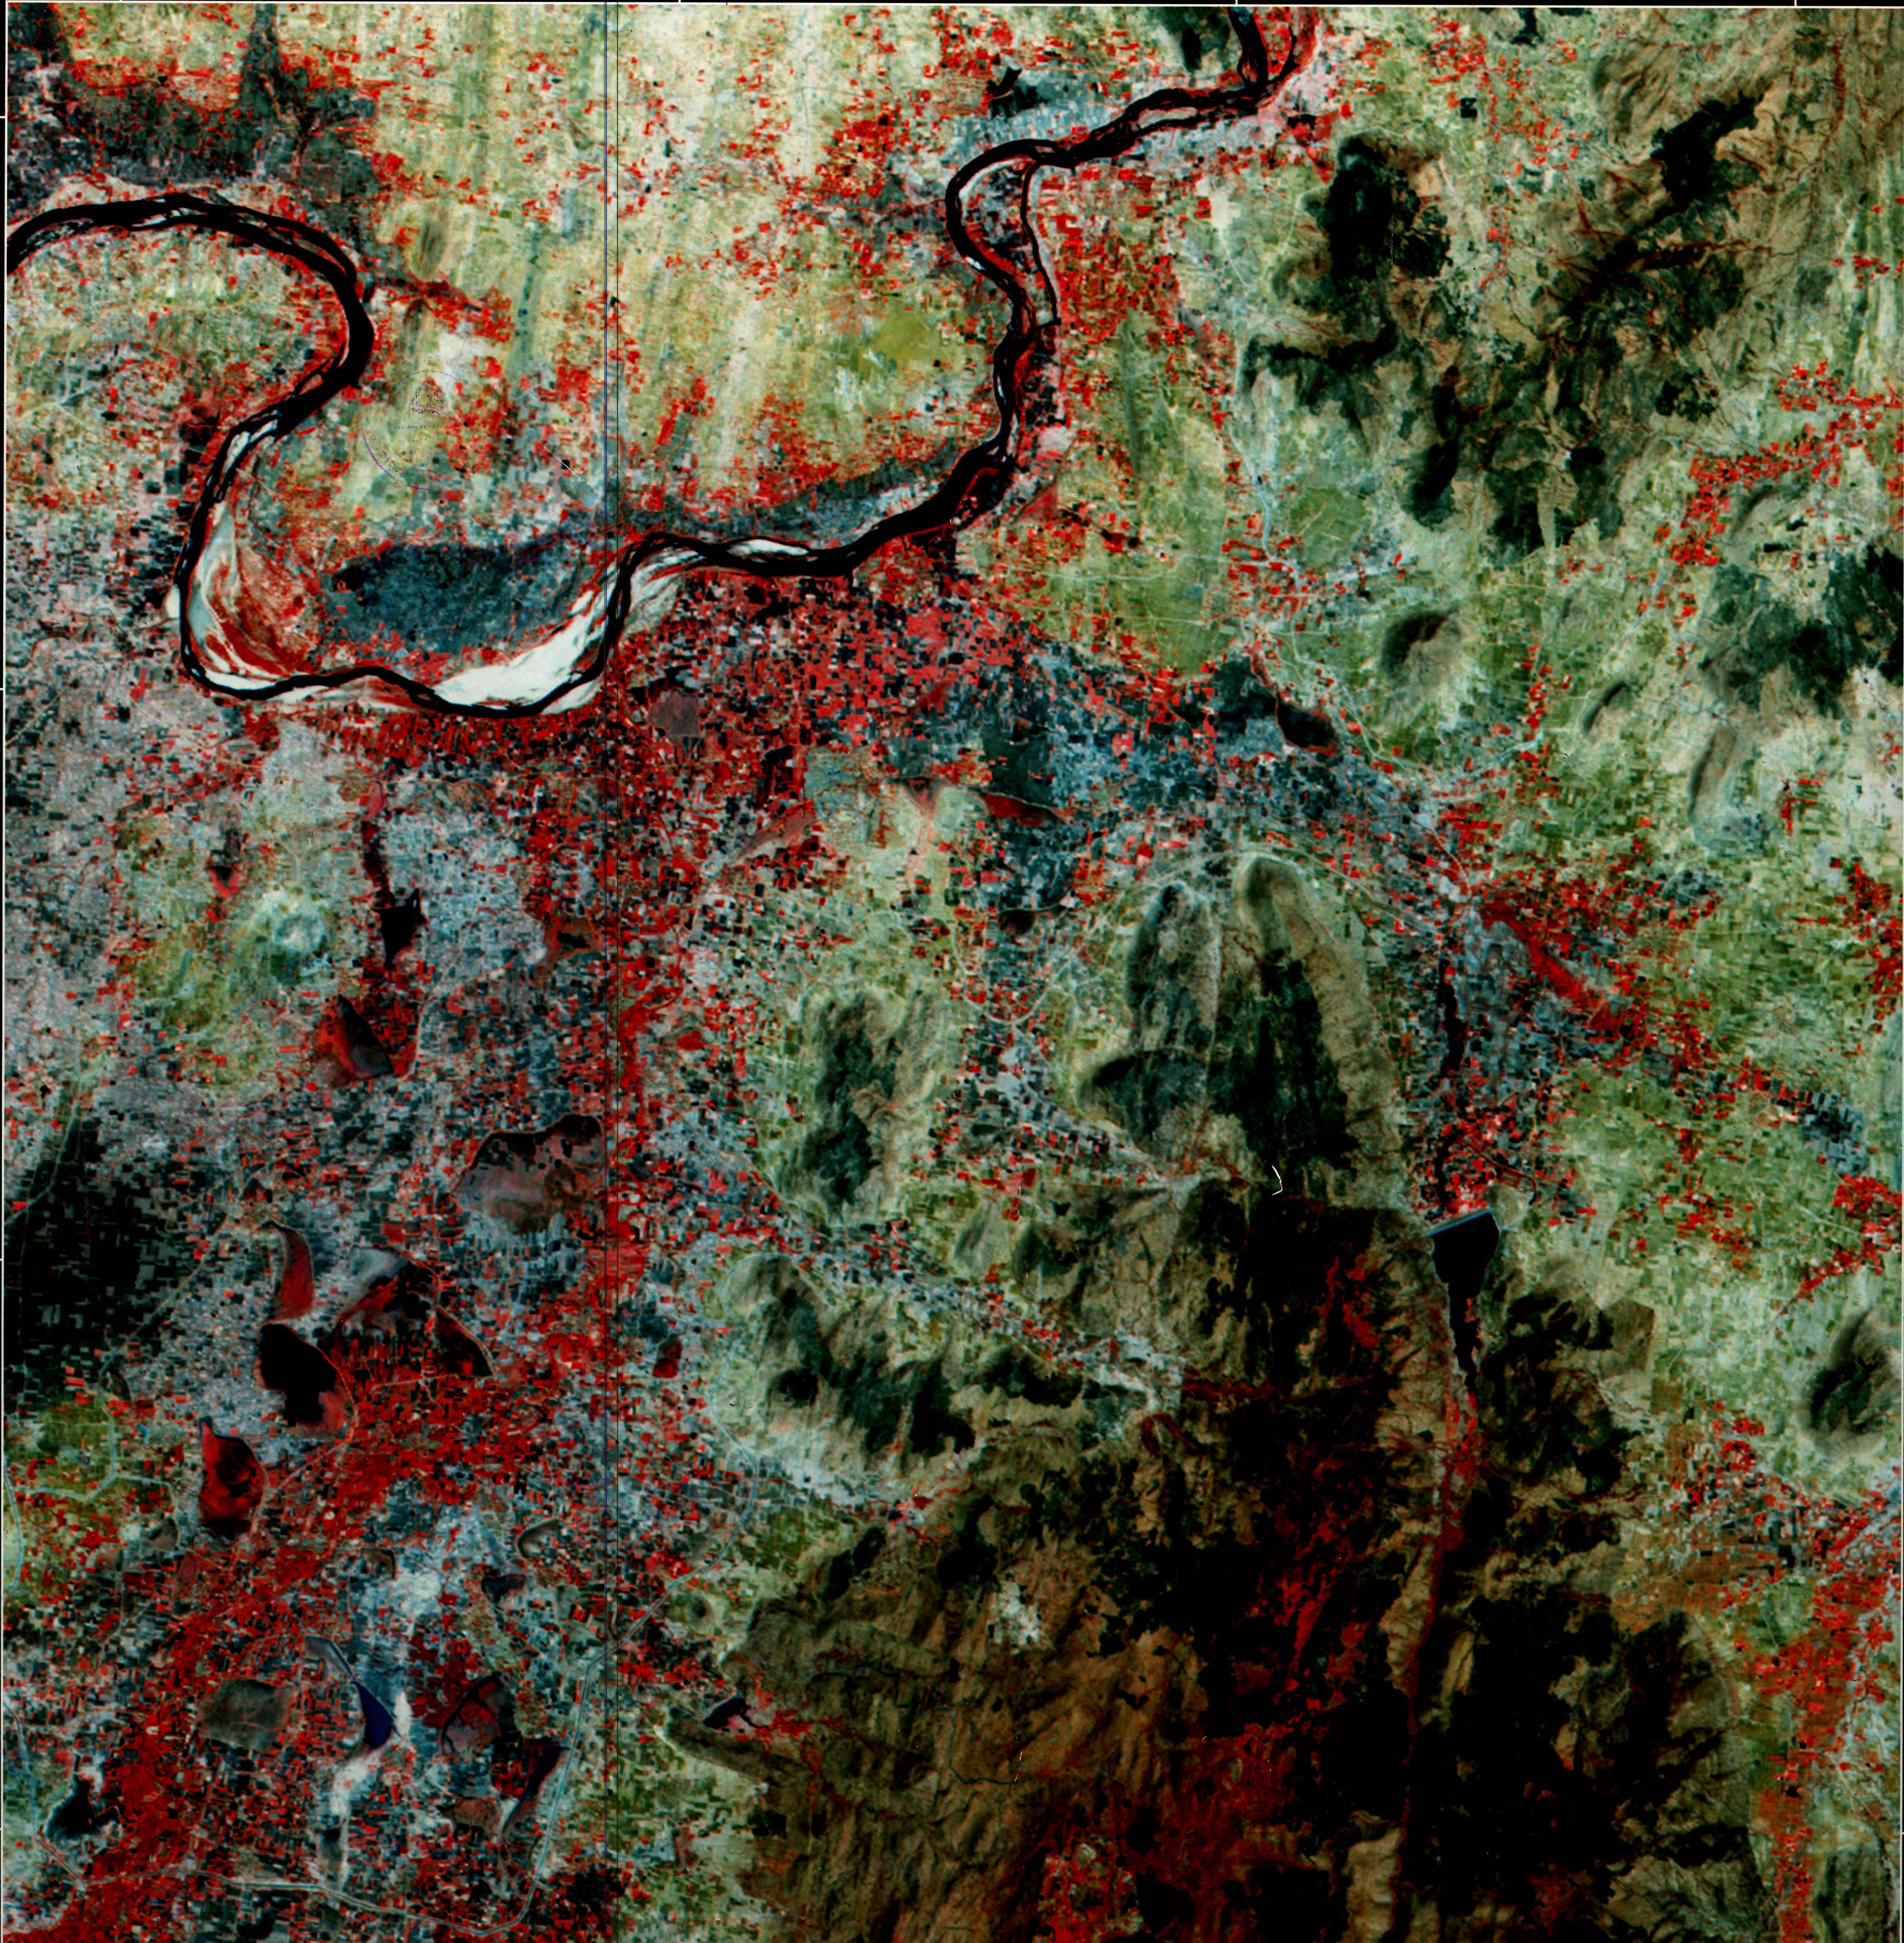
Salt affected land
Salt affected land

Fig. 2 Satellite imagery of salt affected lands-Chamrajnagar District, Karnataka
(Source: Rajan and Meena, 2012)
Reflectance of electromagnetic radiation forms the basis for soil quality assessment. Satellite imageries are developed in false colour composite. Vegetations are shown in red colour, water bodies are shown in black colour and eroded and salt affected lands are shown in white colour. Irregular white patches in the irrigation command of Kabini river shows the salt affected areas (Fig-2).
  - Microwave remote sensing: Microwave remote sensing encompasses both active and passive forms of remote sensing. The microwave portion of the spectrum covers the range from approximately 1cm to 1m in wavelength. Because of their long wavelengths, compared to the visible and infrared, microwaves have special properties that are important for remote sensing. Longer wavelength microwave radiation can penetrate through cloud cover, haze, dust. This property allows detection of microwave energy under almost all weather and environmental conditions so that data can be collected at any time. Passive and active microwave remote sensing are the two types. Passive microwave sensing is similar in concept to thermal remote sensing. All objects emit microwave energy of some magnitude, but the amounts are generally very small. A passive microwave sensor detects the naturally emitted microwave energy within its field of view. This emitted energy is related to the temperature and moisture properties of the emitting object or surface. Microwave remote sensing is used for soil moisture estimation. Soil moisture is an important component of the hydrological cycle. It contributes significantly to the water and energy flux from the surface of the earth, which in turn drives the atmospheric circulation. Remote sensing-based measurement of soil moisture is a better alternative to get this information over a large area (Fig-3)
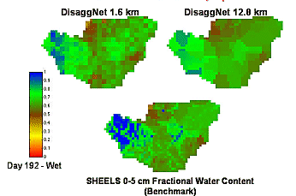

Fig. 3 Soil moisture map in an area developed from microwave remote sensing
Source: (Rajan and Meena, 2012)
Remote sensing data are interpreted for the specific objectives such as cropped areas, water bodies, settlements, forest, hills, rocky area, salt affected land, eroded land, water logged land, mined land etc. Based on above themes thematic maps are prepared. In case of soil quality assessment nature of reflectance are observe. Degraded lands such as salt affected or eroded lands shows high reflectance. Normal soil shows dark in colour with less reflectance. Moist and water logged soils will also appear in dark colour. Assessment of soil quality for any area will be in general, done with a pretext of productivity decline. The area for assessment is demarcated and soil samples are collected from different sites of representative area. Surface or depth wise soil sample are collected in the selected sites. Some of the site characteristic are also collected such as slop per cent, stoniness, drainage pattern, slop direction etc. Soil samples collected from the study are analyzed fro different physical, chemical and biological indicators. Information technologies are using these analytical data. Soil analyzed data are incorporated in data base in the input files as per the requirement.
The data collected from the field using communication technologies will become input for information technologies. Analysis of soil samples brought from the field gives an idea of status of the soil quality indicators such as physical, chemical and biological indicators as follows.
- Soil physical properties such as bulk density, available soil water, micro-aggregates, total porosity
- Soil chemical properties such as electric conductivity, pH, available N, phosphorus, potassium, copper, iron, manganese and zinc.
- Soil biological properties like organic carbon, dehydrogenase and urease activity.
These quality parameters are used in information technologies to assess the soil quality for efficient management.
  - Geographic Information Systems: GIS are another important tool. These systems combine computer cartography with database management software. GIS is used to: a) measure natural and human phenomena and processes from a spatial perspective; b) store these measurements in digital form used a computer database and digital maps; c) analyze collected the measurements. Geographic information systems (GIS) or geospatial information systems is a set of tools that captures, stores, analyzes, manages, and presents data that are linked to location(s). In the simplest terms, GIS is the merging of cartography, statistical analysis, and database technology. GIS are used geography, cartography, remote sensing, land surveying, natural resource management, precision agriculture, photogrammetry, urban planning, etc. GIS digitally creates and "manipulates" spatial areas. GIS developed for an application or purpose may not be necessarily interoperable or compatible with a GIS that has been developed for some other application, jurisdiction, enterprise, or purpose. GIS applications are tools that allow users to create interactive queries (user-created searches), analyze spatial information, edit data, maps, and present the results of all these operations. Soil quality of a region is visualized with geo-reference using GIS techniques. A comprehensive knowledge is acquired when all the soil quality indicators are put together. Land is categorized based on the soil quality and management strategies are planned accordingly (Fig. 4).

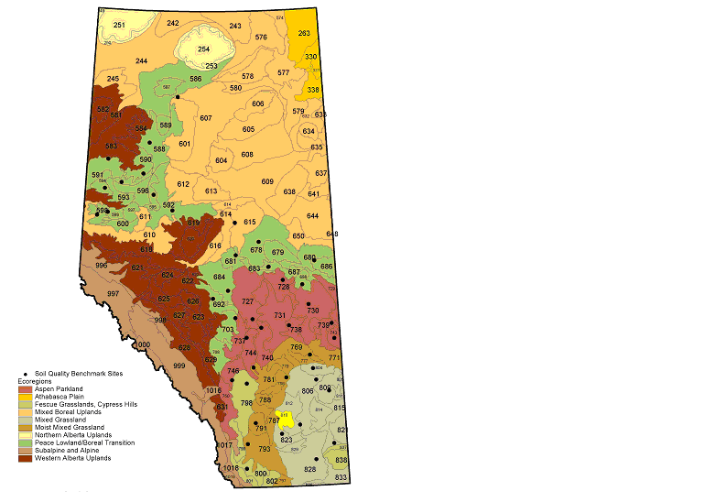

Fig. 4 GIS map showing quality of soil under different ecosystems.
(Rajan and Meena, 2012)
  - Simulation Modeling and Geo-statistics: A computer simulation, a computer model is a computer program, or network of computers, that attempts to simulate an abstract model of a particular system. Computer simulations have become a useful part of mathematical modeling of many natural systems in physics (computational physics), chemistry and biology. Simulations can be used to explore and gain new insights into new technology, and to estimate the performance of systems too complex for analytical solutions.
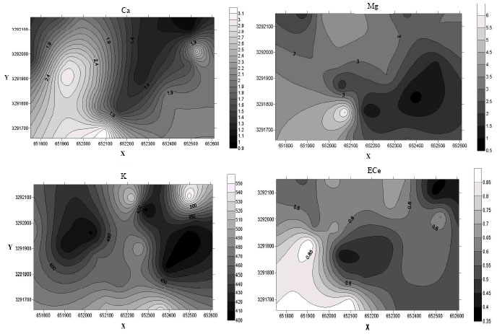

Fig. 5 Variation in soil quality developed by krigging.
Unknown values of soil quality parameters are estimated with known values. Linear models are employed to predict the values in inaccessible areas or other than the measured areas in the girds. Interpolation is done to get the values in all the unmeasured areas using Krigging techniques (Fig-5) Soil quality is assessed exactly in each point and the contour maps are drawn. These developed maps are highly helpful for soil management such as irrigation, site specific nutrient management etc. Temporal variation due to land use from time to time is assessed. Using geo-statistics and GIS, the spatial variability of soil nutrients in rice fields in the Hangzhou–Jiaxing–Huzhou watershed, China, was studied by Liu et al. (2009) after 20 years of altered land management policy due to a shift from a collective farming system to individually-owned family farms. Soil samples, collected in 1982 and 2001, were analyzed for soil organic matter (SOM), total nitrogen (TN), available phosphorus (AP), and available potassium (AK). The spatial variability of each of these soil properties decreased from 1982 to 2001, verifying that the extrinsic factors of the altered land management practices had a weakening effect on the intrinsic factors of soil formation properties. Spatial variability in organic matter content in the year 1982(A) and 2001(B) is shown in Fig-6. Spatial correlation ranges for SOM, TN, and AP in 2001 all decreased from 1982 with the exception of AK. Temporal geographic maps revealed significant changes in soil nutrient concentrations in the form of increases in SOM, TN, and AP and a sharp decline of AK during the period 1982–2001. This result gave an indication of the imbalance among N, P, and K fertilizers applied in the study area.

Fig. 6 Spatial variability in organic matter content in the year 1982(A) and 2001(B)
  - Neural networks: An artificial neural network is a system based on the operation of biological neural networks, in other words, is an emulation of biological neural system. Although computation is advanced these days, there are certain tasks that a program made for a common microprocessor is unable to perform. Artificial neural networks (ANN) are among the newest signal-processing technologies. The field is highly interdisciplinary. An Artificial Neural Network is an adaptive, most often nonlinear system that learns to perform a function (an input/output map) from data. Adaptive means that the system parameters are changed during operation, normally called the training phase. After the training phase the Artificial Neural Network parameters are fixed and the system is deployed to solve the problem at hand (the testing phase). The Artificial Neural Network is built with a systematic step-by-step procedure to optimize a performance criterion or to follow some implicit internal constraint, which is commonly referred to as the learning rule. The input/output training data are fundamental in neural network technology, because they convey the necessary information to "discover" the optimal operating point. The nonlinear nature of the neural network processing elements (PEs) provides the system with lots of flexibility to achieve practically any desired input/output map, i.e., some Artificial Neural Networks are universal mapper .

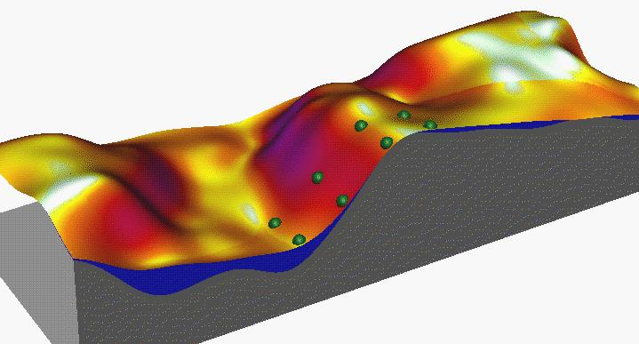

Fig-7. Three dimensional map based on soil quality data showing elevations
Source: (Ranjan and Meena, 2012)
Neural networks is also simulation models and working on non-linear models. Based on the measured values the values are predicted in the unmeasured spots and contours are drawn. Elevation maps are also created to show the difference in soil quality parameters (Fig-7). Indicting soil quality indicators, environmental assessment is also done.Eco-environment quality evaluation is an important research theme in environment management. Shi and Li (2007) used the neural network for the regional eco-environmental quality evaluation. In the present study, Fuzhou city in China was selected as a study area and a limited number of 222 sampling field sites were first investigated in situ with the help of a GPS device. Every sampling site was assessed by ecological experts and given an Eco-environment Background Value (EBV) based on a scoring and ranking system. The higher the EBV, better the ecological environmental quality. Then, three types of eco-environmental attributes that are physically-based and easily-quantifiable at a grid level were extracted: (1) remote sensing derived attributes (vegetation index, wetness index, soil brightness index, surface land temperature index), (2) meteorological attributes (annual temperature and annual precipitation), and (3) terrain attribute (elevation). A Back Propagation (BP) Artificial Neural Network (ANN) model was proposed for the EBV validation and prediction. A three-layer BP ANN model was designed to automatically learn the internal relationship using a training set of known EBV and eco-environmental attributes, followed by the application of the model for predicting EBV values across the whole study area (Fig. 8). It was found that the performance of the BP ANN model was satisfactory and capable of an overall prediction accuracy of 82.4%, with a Kappa coefficient of 0.801 in the validation. The evaluation results showed that the eco-environmental quality of Fuzhou city is considered as satisfactory. Through analyzing the spatial correlation between the eco-environmental quality and land uses, it was found that the best eco-environmental areas were related to forest lands, whereas the urban area had the relatively worst eco-environmental quality. Human activities are still considered as a major impact on the eco-environmental quality in this area.

Fig-8 Eco-environmental quality map drawn using artificial neural network
- ICT for Efficient Water Management
For instance, agricultural sector typically uses about 70% of a nation’s water resources but increasing urbanization and industrial development, the water resources of many nation’s are being over-utilized, with long-term negative consequences. Farmer must learn how and be convinced of need to use water, efficient technologies (e.g., drip irrigation) and/or to shift to more water-efficient crop and livestock systems. Also some technologies, such as water harvesting, require more labour input, while most irrigation technologies require substantial capital investment and higher operating cost. Water is a prime natural resource, a basic human need and a precious national asset. Indeed, sustainable water management policies have been high on the agenda of many governments around the world and the looming global impact of climate change in terms of sea level rise, longer drought periods and flooding is adding more pressure on the availability of fresh water resources to sustain the growing demands of increasing populations and economic growth.
India has a typical monsoon climate and estimated rainfall is about 1170 mm. The total of average annual rainfall, snowfall and glacier melt in terms of volume is about 4000 billion cubic meters (bcm). However, due to losses through evaporation and evapo-transpiration, the water availability has been assessed to be about 1869 bcm. Even this available water cannot be fully utilized due to topographical constraints and hydrological features and utilizable water has been estimated to be about 1123 bcm comprising of 690 bcm of surface water and 433 bcm of replenishable ground water. Besides, very large temporal and spatial variations are observed in rainfall and water availability in India. For instance, in the northwest desert of Rajasthan, the average annual rainfall is lower than 150 mm/year. In the broad belt extending from Madhya Pradesh and Maharashtra to Tamil Nadu, through parts of Andhra Pradesh and Karnataka, the average annual rainfall is generally lower than 500 mm/year. At the other extreme, more than 10 meters (m) of rain fall on the Khasi hills in the northeast of the country in a short period of four months. On the west coast, Sub-Himalayan West Bengal and in the northeastern states of Assam, Meghalaya, and Arunachal Pradesh the average annual rainfall is about 2,500 mm. In this view, effective and efficient water management is becoming more and more important for India.
ICTs provides a unique opportunity for stakeholders involved in water management process, and helps them to obtain information about a number of physical and environmental factors. Besides, ICT also provides benefits in water management process such as real-time monitoring and control at wide scale; integrated management and decision support based on data collection and aggregation; empowering user with real time information to create awareness and stimulate behavioral change; water smart meters and ICT tools to support leak detection, automated meter reading through communication networks.
- Applicability of ICT based Tools in Different Water Management Areas
- Mapping of Water Resources and Weather Forecasting
- Remote sensing from satellites
- In-situ terrestrial sensing systems
- Geographical Information Systems
- Sensor networks and Internet
- Asset Management for the Water Distribution Network
- Buried asset identification and electronic tagging
- Smart pipes
- Just in time repairs/Real time risk assessment
- Setting up Early Warning Systems and Meeting Water Demand
- Rain/Storm water harvesting
- Flood management
- Managed aquifer recharge
- Smart metering
- Process Knowledge Systems
- Just In-time Crop Irrigation
- Geographical Information Systems
- Sensor networks and Internet
Therefore, the experiences of effective ICT tools such as Decision Support System and Geographical Information System in water management is presented below.

Decision Support Systems (DSS)
The complexity of water resources management and the difficulties of making decisions about the allocation of water resources are crucial. In such situations, decision support systems (DSS) are intended to assist to make strategic and rational decisions. Decision Support Systems is a specific class of computerised information systems that supports organizational decision-making activities. A properly designed DSS is an interactive software-based system intended to help decision makers compile useful information from raw data, documents and personal knowledge, to identify and solve problems and make decisions. A DSS helps structural decision-making processes and support the analysis of complex situations.
Ruaha Basin Decision Aid (RUBDA): Case Study of Tanzania
In Tanzania, the National Water Act highlights ‘water resources models and decision support systems’ as instruments for the implementation of water policy and a means of achieving an integrated multi-sectoral approach. However, concerns have been expressed about the utilization of DSS for decision-making. These concerns focus on the lack of communication between developers and users, lack of documentation and support services and the lack of involvement of a subjective and value-dominated human element. In this context “Raising Irrigation Productivity and Releasing Water for Inter-sectoral Needs (RIPARWIN) Project” of Tanzania developed Ruaha Basin Decision Aid (RUBDA). The RUBDA is a computer software program intended to support water resource managers in the Rufiji Basin Water Office (RBWO) and District Councils to make decisions about the allocation of water between different stakeholders. It is based on several components, comprising a hydrological model, an outcome model and a water management module, and is accompanied by a ‘Geographical Information System’. The structure of Ruaha Basin Decision Aid is presented in Figure-9

Figure-9: Structure of Ruaha Basin Decision Aid
Source: (Cour, 2005)

This RUBDA decision support system has significantly enhanced the ability of the RBWO to perform its core functions, namely, assessing new applications for water rights and matching water abstractions to available water resources. By analyzing hydrological and socioeconomic condition, it also provides the impacts of different of resource allocation, empowered to evaluate different water allocation decisions and useful for monitoring of ongoing program in the basin of Tanzania (Matthew, et al, 2007).
Geographical Information System (GIS) in Watershed Management
During last some decades, country has been taken large initiatives in the form of massive watershed development programs like Integrated Watershed Development Program, National Watershed Development Program, and Watershed Development in Shifting Cultivated Areas etc for efficient water management and community development. All these programs made significant impact on water resource conservation and socio-economic development of watershed community. In this context, Geographic Information Systems (GIS) in watershed programs will play critical roles in all aspects of watershed management, right from assessing watershed conditions, modeling impacts of human activities on water management and to visualize the impacts of alternative management scenarios. GIS application in watershed management has changed from operational support (e.g., inventory management and descriptive mapping) to prescriptive modeling and tactical or strategic decision support system. Henceforth researchers, resource planners and policy makers have to be realizing the power of GIS and its unique ability to enhance watershed management. According to Tim and Mallavaram (2003) the role of GIS in watershed management as below;
- Watershed Characterization and Assessment: Data gathered from Geographical Positioning System (GPS) surveys and from environmental remote sensing systems can be fused within a GIS for a successful characterization and assessment of watershed functions and conditions.
- Management Planning: Further, characterization and assessment information can be combined with other data sets to improve understanding of the complex relationships between natural and human systems as they relate to land and resource use within watersheds. GIS provides a common framework ‘spatial location’ for watershed management because, watershed data and watershed biophysical processes have spatial dimensions. GIS can be a powerful tool for understanding these processes and for managing potential impacts of human activities. Further, the linkage between GIS, Internet and environmental databases is especially helpful in planning studies where information exchange and feedback on a timely basis is very crucial and more so when there are several different agencies and stakeholders involved.
- Watershed Restoration and Analysis of Alternative Management Strategies: Watershed restoration studies generally involve evaluation of various management alternatives. In this view, GIS provides the perfect environment to accomplish that efficiently and accurately. It also provide a platform for collaboration among researchers, watershed stakeholders, and policy makers, significantly improving consensus building and offering the opportunity for collaborative work on interdisciplinary environmental issue.
- Watershed Policy Analysis and Decision Support: Policy planning and management are based on a generic problem-solving process which begins with problem definition and description, involves various forms of analysis which might include simulation and modeling, moves to prediction and thence to prescription or design which often involves the evaluation of alternative solutions to the problem. GIS can assist the decision maker in dealing with complex management and planning problems within a watershed, providing geo-processing functions and flexible problem solving environments to support the decision research process.
- ICT in Water Management: Strategies and Future Trend
There is ample potential for effective use of ICT in agriculture and initiatives are promising. However, much still remains to be done. Knowledge transfer should take into account farmers’ point of view, with the aim of building on their knowledge and capitalize it. Thus information technology, jointly with communication sciences, can play a big role in blending different perspectives. Several future trends of great importance have emerged as:
- Strong ‘Network of Information System’ for water and soil management at National, State and District Level,
- Pluralistic partnership between public, private, non-government organizations and water users and soil conservation association,
- Capacity building of different stakeholders in the areas of ICTs,
- Application of ICT in ongoing watershed programs for its effective implementation, monitoring and evaluation,
- Designing of different ICT based modules decision support system/expert system for water application methods, water conservation, water harvesting system etc.
- Enhancing water use efficiency by using ICTs at field situation.
- Pilot program for ‘ICT enabled Soil and Water Management System’ and its up scaling
- Converging of media and tools for communication
- Increased web based storage of agricultural information;
- Cheaper and improved connectivity for rural communities;
- Increased recognition by governments for use of ICT in rural development,
- Increased tailor made, quality agricultural information services etc.
- Emerging Challenges of Water Management
The water management is the activity of planning, developing, distributing, managing, and optimum use of water resources under defined water polices and regulations. It may include management of water resources, irrigation methods and water table. The water management sector has emerged number of challenges before Indian policy makers, technocrats, extension professionals, water users, farmers and other stakeholders.
- Water Availability: Reducing per capita water availability due to increasing population, deterioration in quality, over exploitation of ground water resources leading to decline in the ground water table in some part of country. The per capita availability of water in 1951 was assessed to be 5177 cubic meter, which is reduced to about 1650 cubic meter. However, the demand for water for various purposes is always increasing due to phenomenon of liberalization and globalization.
- River Pollution: All of India’s fourteen major river systems are heavily polluted, mostly from the 50 million cubic metres of untreated sewage discharged into them each year.
- Water Conflicts: Severe water shortages have already led to a growing number of conflicts across the country. Nearly 90 % of India’s territory is drained by inter-state rivers. The lack of clear allocation rules and uncertainty about water sharing has led to major disputes between states.
- Ground Water Pollution: The primary reasons are industrial pollution and extensive farming leading to agrochemical pollution of the groundwater. In case of industries, it is due to lack of treatment of effluents that are pumped into rivers and streams leading to groundwater pollution. Excessive use of chemicals and fertilizers and pesticides in agriculture sector is also a major cause of pollution.
- Crumbling Infrastructure: India’s past investments in large water/irrigation infrastructure have yielded spectacular results with enormous gains in food security in particular and agricultural development in general. However, much of this infrastructure is now crumbling and faced with poor water supply services. Farmers and urban dwellers alike have resorted to helping themselves by pumping out groundwater through tube wells. This resulted into most populated and economically productive parts of the country are in crisis situations due declined ground water table.
- Inadequate storage capacity: Developed and arid countries (United States, Australia) have built over 5000 cubic meters of water storage per capita and the countries like South Africa, Mexico, Morocco and China can store about 1000 cubic meters per capita. But, India is storing only 200 cubic meters per person. India can store only about 30 days of rainfall, compared to 900 days in major river basins in arid areas of developed countries.
- Aquifer Depletion: Already about 15 % of India’s food is being produced using non-renewable ‘mined’ groundwater.
- Enhancing Water Use Efficiency: The agricultural rate of growth depend on predominant factors like economic and ecological access for augmenting productivity, profitability and conserving natural resources especially water. Indian water use efficiency seldom exceeds 40%. Available estimates indicate that by 10% increase in water use efficiency, country can gain more than 50 million tones of food grains from the existing irrigated area. Though India’s irrigated area is about one third of the world, the area under drip and sprinkler irrigation is very meager compared to total drip and sprinkler area in the world.
- Ever-growing Water Demand: The ‘National Commission for Integrated Water Resources Development (NCIWRD)’ has assessed that about 83% of water is used for agriculture especially for crop irrigation and, remaining for domestic, industrial and other purposes. The Commission has projected water demand of 1180 bcm for the year 2050. Although the requirement for irrigation water would increase over the time, the share of irrigation water in the overall demand has been estimated to reduce from the present level of about 83.00% to about 69.00% by the year 2050. It can only be ensured by improving the efficiency of both surface water and ground water systems.
Conclusions
With increasing challenges before India, the National Water Policy-2002 envisaged that establishment a well-developed information system for water related database at national and state level with a network of data banks by integrating and strengthening existing central and state level stakeholders. The information system should comprises standards for coding, classification, processing of data and methods or procedures for its collection and promoting free exchange of data among various agencies. Apart from data regarding water availability and actual water use, system should also include comprehensive and reliable projections of future demands of water for diverse purposes. With development of modern technologies, ICTs are of immense use in Sustainable Natural Resource Management. These technologies are time and money saving, accurate compared to conventional assessment. Products of these technologies help the scientists and policy makers for taking appropriate decision in agriculture production. Many industrially developed countries such as the U.S., Canada, Australia and New Zealand, have increasingly shifted the focus of their public extension systems away from technology transfer to training farmers how to use Sustainable Natural Resource Management practices.
It is important to recognize that the dissemination of these land and water-use management practices are largely knowledge-based; therefore, developing countries will be required to make substantial investment in public extension to train small and medium-scale farmers how to use Sustainable Natural Resource Management (SNRM) practices. First, farmers need to learn about long-term consequences of land and water degradation for themselves and the next generation. Second, they need to know how to utilize sustainable land and water-use management practices to correct these problems. Third, most subsistence farmers cannot afford to adopt capital intensive technologies, without first increasing their household incomes. FFS is the best example of a well organized approach of educating farmers about Sustainable NRM practices (van den Breg, 2004).

References:
Cour, J. (2005). Ruaha Basin Decision Aid user manual. RIPARWIN report.
Doran,D. and Parkin, T.B. (1994) Defining soil quality for sustainable environment. In: Soil Science Society of America Special Publication NO.35 (J.W. Doran, D.C. Coleman, D.F. Bezdicekand and B.A. Stewart, Eds.)Soil Science Society of America, Madision, WI
Friedli, B., Tobias, S. Fritsch, M., (1998) Quality assessment of restored soils: combination of classical soil science methods with ground penetrating radar and near infrared aerial photography? Soil & Tillage Research 46: 103-115.
International Telecommunication Union (2010). ICT as an Enabler for Smart Water Management, http://www.itu.int/dms_pub/itut/oth/23/01/T23010000100001PDFE.pdf
Karlen, D.L. and Eash, N.S. and Unger, P.W. (1992). Soil and crop management effects on soil quality indicators. American Journal of Alternate Agriculture, 7:48-55
Kumar, Abhay and Singh, Krishna M., Role of ICTs in Rural Development with Reference to Changing Climatic Conditions (March 23, 2012). ICT for Agricultural Development Under Changing Climate, Krishna M. Singh, M.S. Meena, eds., Narendra Publishing House, 2012. http://dx.doi.org/10.2139/ssrn.2027782
Liu, Xingmei, Zhang Weiwen, Zhang, Minghua , Ficklin, L. Darren, Wang Fan, 2009, Spatio-temporal variations of soil nutrients influenced by an altered land tenure system in China. Geoderma 152: 23–34.
Matthew P. McCartney, Bruce A. Lankford and Henry Mahoo, (2007). Agricultural Water Management in Water Stressed Catchment: Lessons from RIPARWIN Project, Research Report 116 of International Water Management Institute, Sri Lanka.
Meena, M. S., Singh, Krishna M. and Singh, R. K. P., ICT-Enabled Extension in Agriculture Sector: Opportunities and Challenges in Climate Change Situation (March, 23 2012). ICT for Agricultural Development Under Changing Climate, K.M.Singh, M.S.Meena, eds., Narendra Publishing House, 2012. Available at SSRN: http://ssrn.com/abstract=2027803
Rajan, K, and Meena, M. K. (2012). ICT for soil quality assessment under changing climate scenario pp: 247-260. In: ICTs for Agricultural Development under Changing Climate. Ed. K. M. Singh and M. S. Meena, Narendra Publishing House, Delhi: ISBN-978-93-80428-45-1
Shi, Zhou and Li Hongyi, (2007). Application of artificial neural network approach and remotely sensed imagery for regional eco-environmental quality evaluation. Environ Monit Assess. 128:217–229
Singh, Krishna M. and Meena, M. S., Conservation Agriculture: Economic Perspective and Future Challenges (Jan 20, 2012). http://dx.doi.org/10.2139/ssrn.2026336

Singh, R. K. P. and Singh, Krishna M., Climate Change, Agriculture and ICT: An Exploratory Analysis (March 23, 2012). ICT For Agricultural Development Under Changing Climate, pp. 17-28, Krishna M. Singh, M.S. Meena, eds., Narendra Publishing House, New Delhi, 2012 . http://dx.doi.org/10.2139/ssrn.2027780
Tim, U. Sunday and Mallavaram, Sumant. (2003). Application of GIS Technology in Watershed-based Management and Decision Making, Watershed Update, 1(5). http://www.awra.org/committees/techcom/watershed/pdfs/0105WU.pdf
Van den Berg, H. (2004) IPM farmer field schools: a synthesis of 25 impact evaluation. Prepared for the Global IPM facility of Wageningen University, Netherland. 53 pp.

Senior Scientist, Division of Socio-Economics & Extension, ICAR-RCER, Patna, India
Head, Division of Socio-Economics & Extension, ICAR-RCER, Patna, India

